**Student Name: TIN VU V00830285**

**CMSC 311 Computer Organization**

**LAB 3: Machine Language programming Using LC-3 Simulator**

**Instructor:** Dr. Cang Ye **Email:** [cye@vcu.edu](mailto:cye@vcu.edu) Office & Hours: E2240, TR 12-1 PM

**TA:** Lingqiu Jin **Email:** [jinl@mymail.vcu.edu](mailto:jinl@mymail.vcu.edu) Office & Hours: E2264, MW 2-3 PM

SOURCE CODE:

0011 000000000000; Start the program at location x3000

0101 001 001 1 00000; Clear register 1

0010 101 000011100; Assign R5 to memory location x301E

0010 110 000011100; Assign R6 to memory location x301F

1001 110 110 111111; reverse the sign of value in R6

0001 110 110 1 00 001; get the value in R6, add 1 and put it back into R3 for comparison

0001 100 101 000 110; Add R5 and R6 and put the value into R4

0000 101000000001; If the above step (R4) is zero then continue, otherwise skip the next step and leave R1 as 0

0001 001001100001; Add 1 into R1 (show the result as equal .i.e. 1)

1111 000000100101; HALT

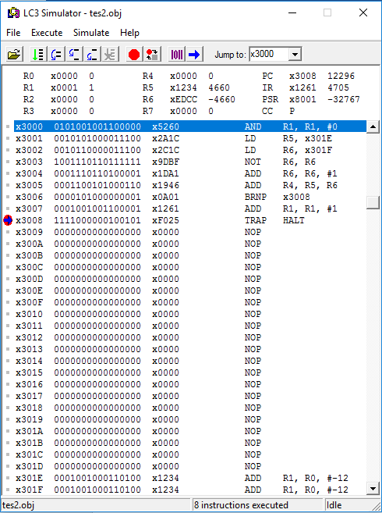 **VALUE IN BOTH STORING LOCATION is x1234**

